MITHIBAI COLLEGE
Department of Computer Science
BSC-II sem –III (2026-27)
__________________________________________________________________________Practical-8 Implementing AWT and Event Handling
Date: -12/09/2026 Submission Date: - 19/09/2026
Write-up:
- Event Delegation Model
- Any 5 types of Listeners
- Inner and Anonymous class
- Adaptor classes

- Design the following using awt : Implement Event handling for the previous practical (7)

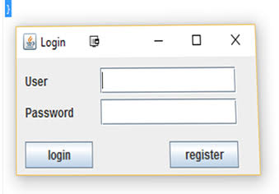
User is your gmailid and password is your 4 chars of first name and DOB in ddmmyyyy

- Implement the basic operations
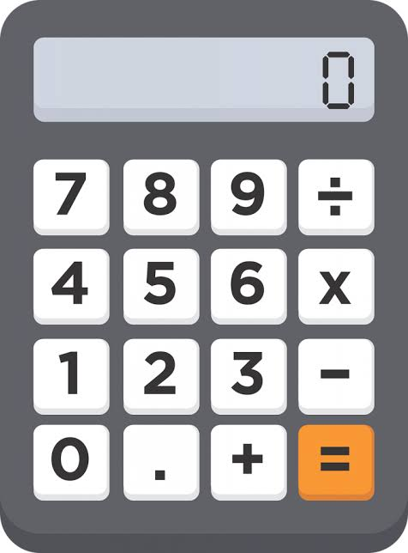

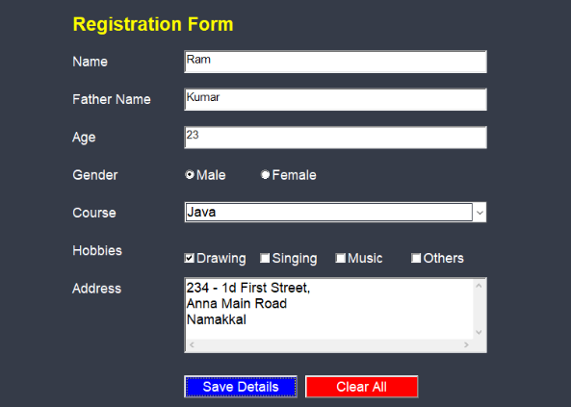
- Print all the input on the console.
- Create a file of all the input values.

********** ****************good luck******be your own*********

